**Name _____________________________**

**Date** **_____________________________**

**Brief-Constructed Response**

**Solar Activity and Climate Change**

Climate change is an accepted part of life as part of the dynamic system that is Earth. The Earth changes, and so will our climate. The debatable part of climate change is how much of it is anthropogenic, and how much we humans can adjust before Earth is uninhabitable for ourselves. Scientists are divided about the severity of global warming. There are many factors to climate change, including incoming solar radiation, manmade greenhouse gases, particulate matter in the atmosphere from pollution or volcanic eruptions, and ocean temperatures and circulation patterns.Refer to the graph below for some insights on one aspect of global warming. Use the graph to answer the following questions.

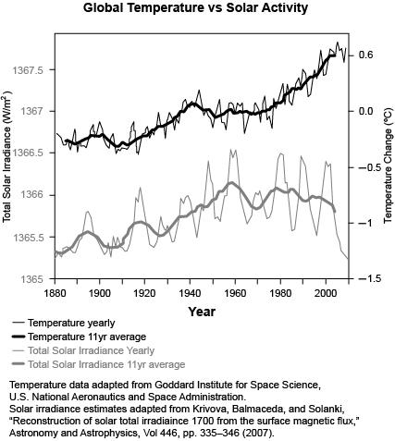

**Name _____________________________**

**Date** **_____________________________**

**Brief-Constructed Response**

1. Scientists are divided about the causes of global warming. There is some debate about the contribution of solar activity to the current warming trend.Citing data from the graph, provide an analysis of the relationship between solar activity and global temperatures over time
2. What kind of additional information could add to this graph so a model of future global temperature change could be improved?